* Purpose : Classwork.
* Date : 31/12/2025
* Author : Vikas Srivastava
* ID : 55984
* Batch ID : 25SUB4505

- Code : Write a program to demonstrate the use of function pointers in C by creating a simple calculator, where different arithmetic operations are performed by passing function pointers to a common calculation function.
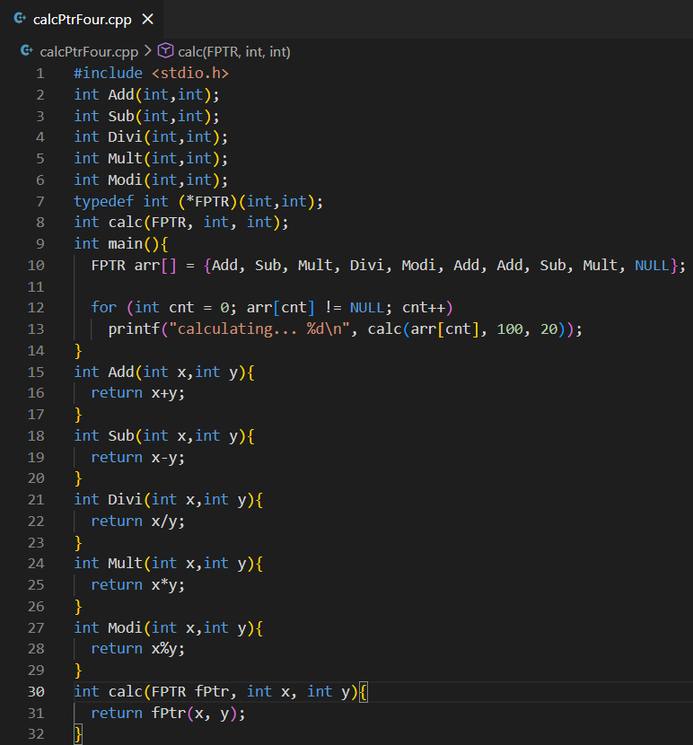
Output :
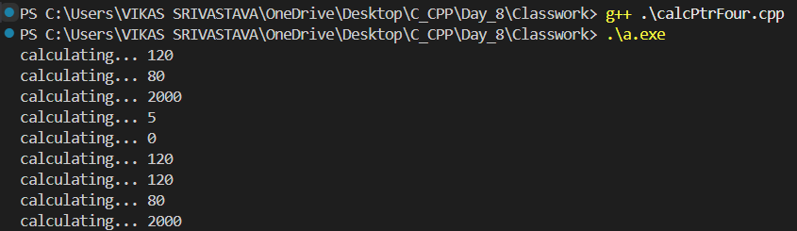

- Code : Write a program to demonstrate how function pointers can be passed as arguments to another function in C, allowing the same calculation function to perform different arithmetic operations dynamically.
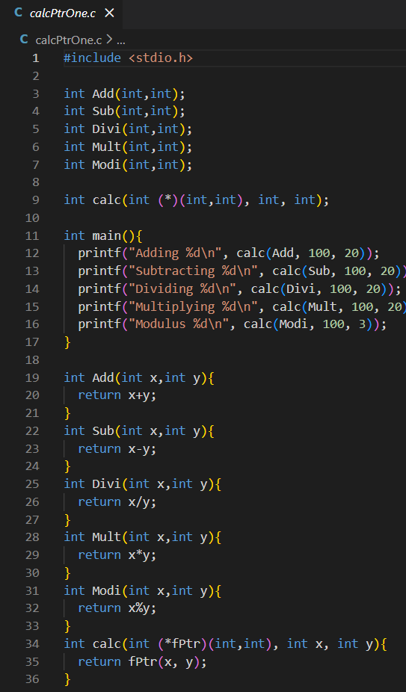
Output :
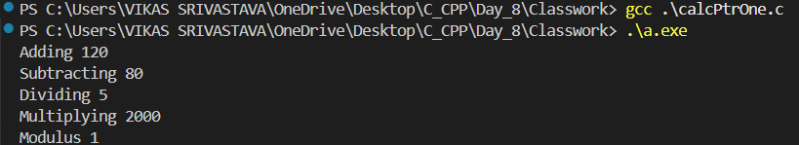

- Code : Write a program to demonstrate the use of function pointers in C++ with the using keyword (type alias), where arithmetic functions are passed to a common calculator function to perform different operations dynamically.
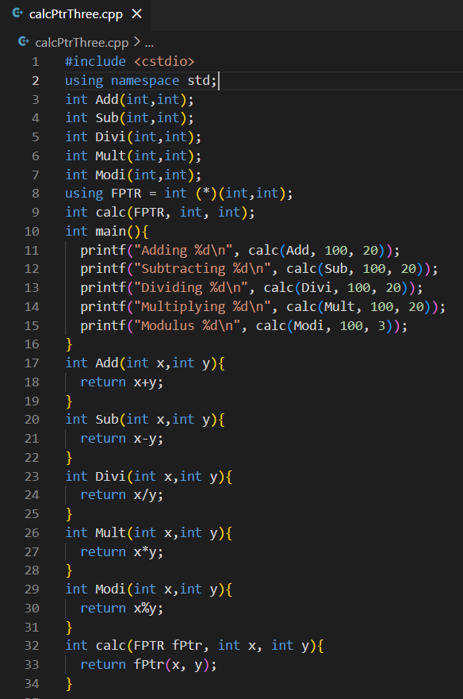

Output :
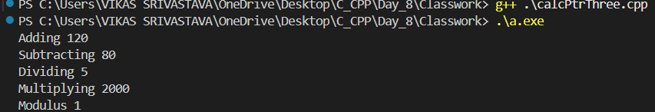

- Code : Write a program to demonstrate the use of function pointers in C, where different arithmetic operations (addition, subtraction, multiplication, division, modulus) are passed as arguments to a common calculation function to perform operations dynamically.
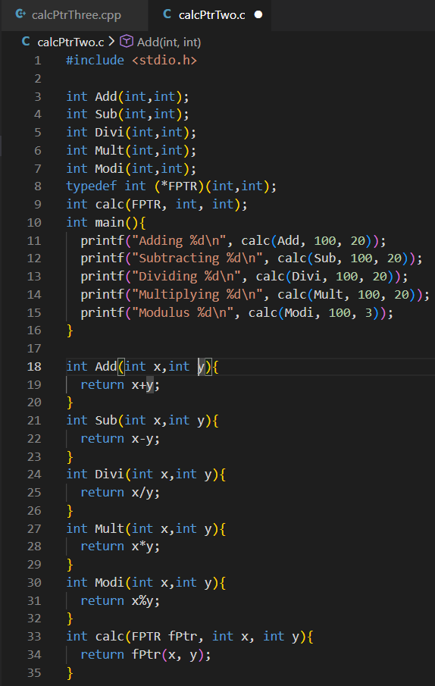
Output :
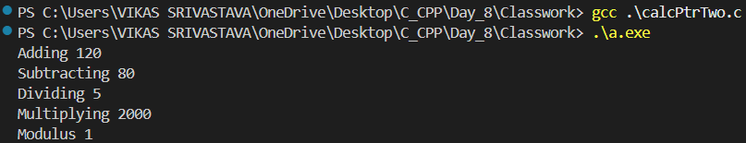

- Code : Write a program to demonstrate multiple inheritance in C++, where a derived class inherits from two base classes containing functions with the same names, and the scope resolution operator (::) is used to explicitly specify which base class function to invoke.
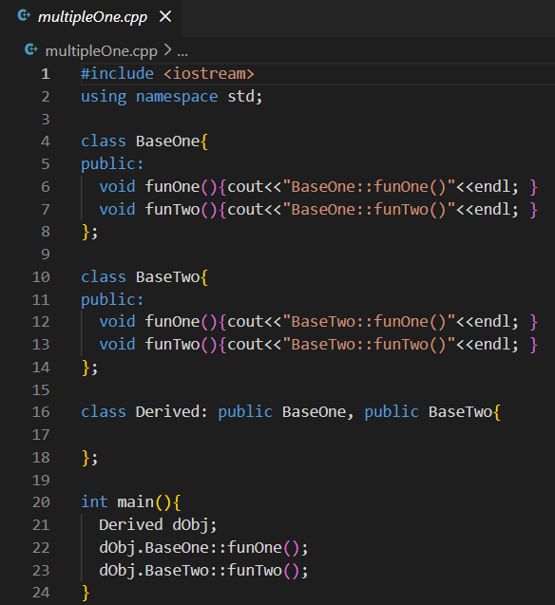
Output :
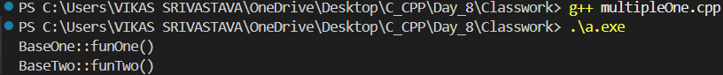

- Code : Write a program to implement a custom MyString class in C++ that manages strings using dynamic memory allocation, demonstrating deep copy through a copy constructor, copy assignment operator, overloaded assignment for C-strings, destructor, and stream insertion (<<) operator overloading to safely handle memory and display string details.
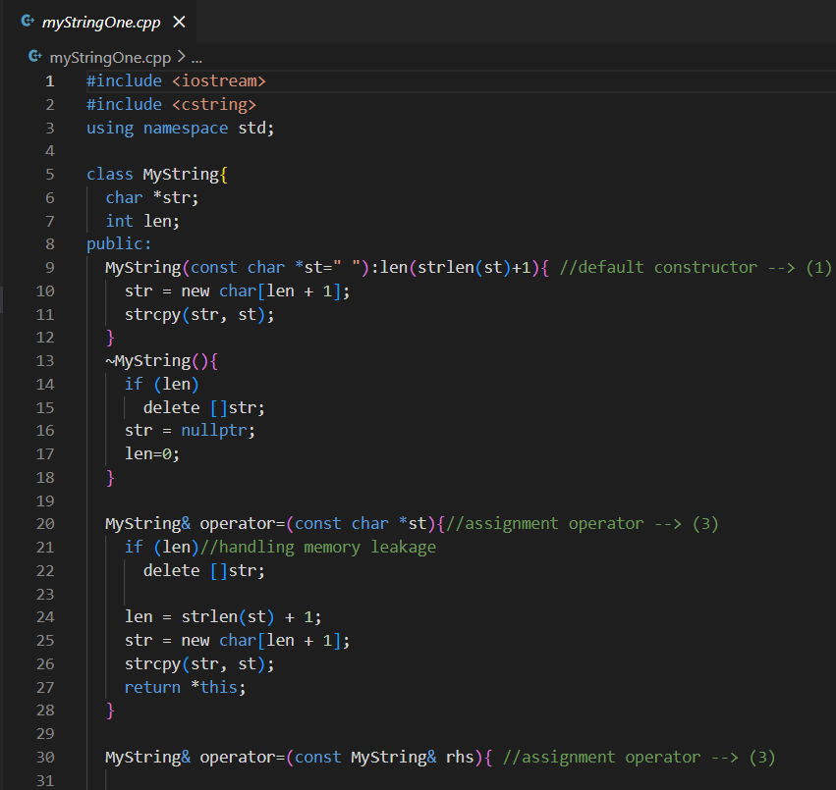
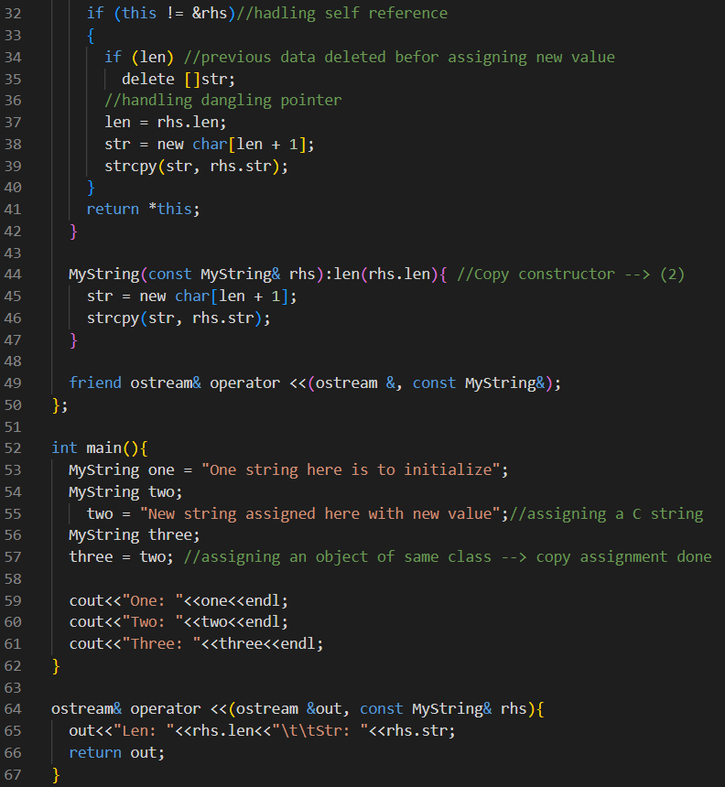
Output :
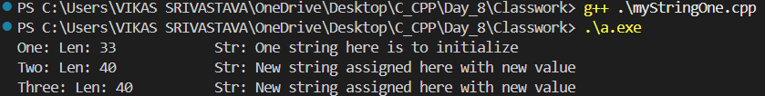

- Code : Write a program to demonstrate assignment operator overloading in C++, where a class overloads the assignment operator to handle assignment from a primitive data type as well as assignment from another object of the same class, ensuring proper value copying and object behavior.
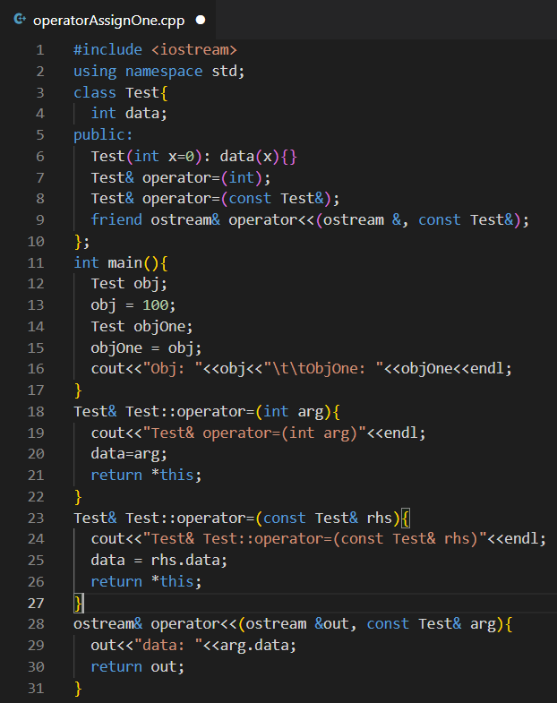
Output :

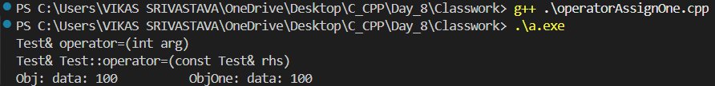

- Code : Write a program to demonstrate function overriding without virtual functions in C++, where a base class pointer points to both base and derived class objects, but the base class function is called in both cases due to static (compile-time) binding.

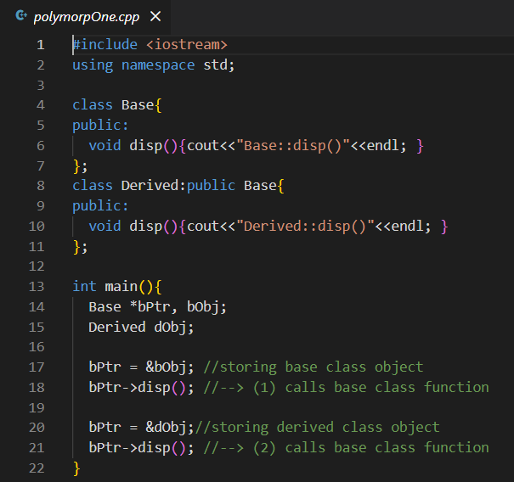
Output :
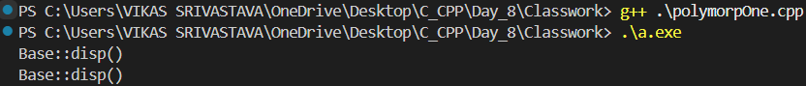
- Code : Write a program to demonstrate runtime polymorphism in C++ using virtual functions, where a base class pointer or reference calls the overridden functions of the derived class based on the actual object type at runtime, achieving dynamic binding.
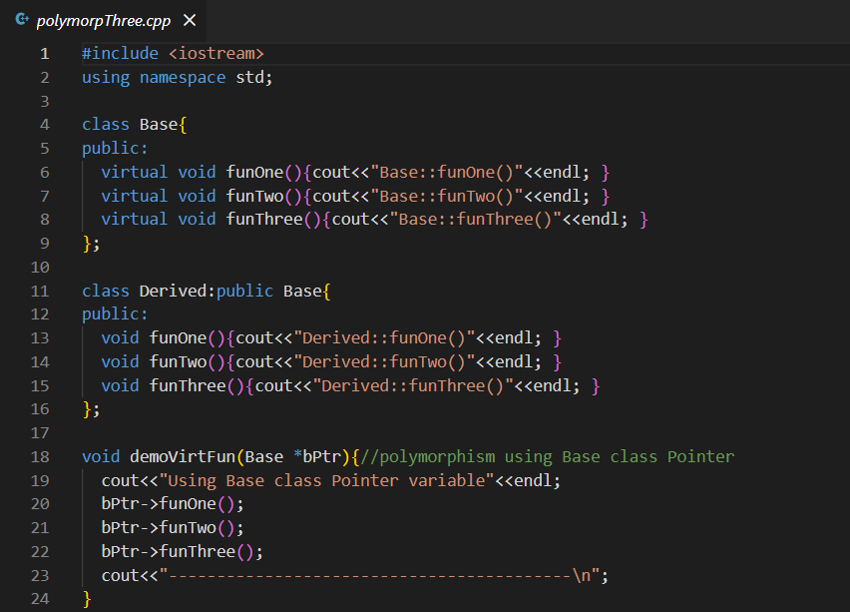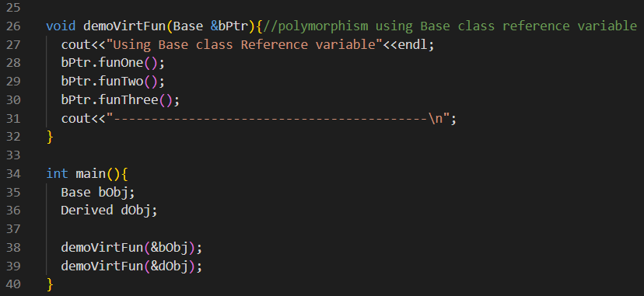
Output :
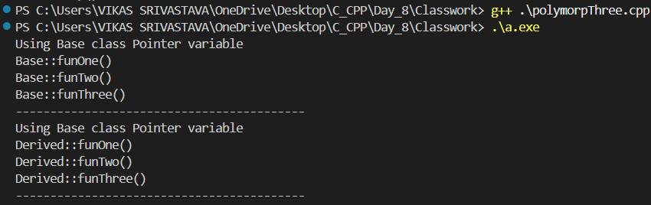

- Code : Write a program to demonstrate function overriding using virtual functions in C++, where a base class pointer calls the appropriate disp() function based on the actual object type at runtime, illustrating dynamic binding and runtime polymorphism.
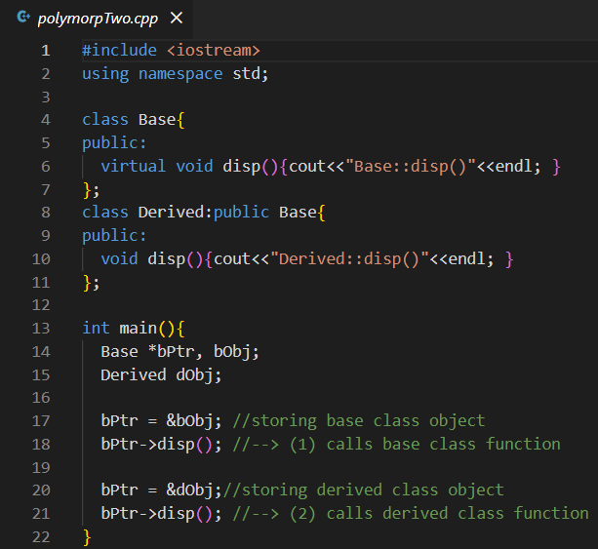
Output :
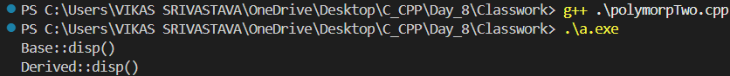

- Code : Write a program to demonstrate the use of function pointers with void return type in C, where functions are passed as arguments to another function and invoked dynamically through the function pointer.
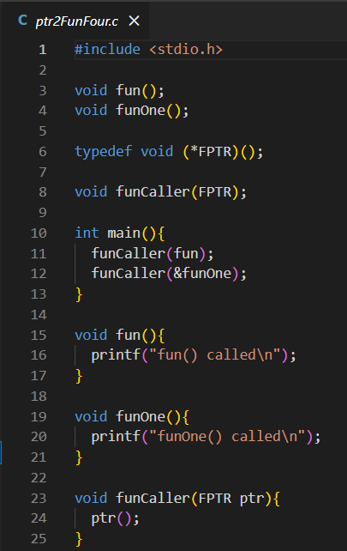
Output :
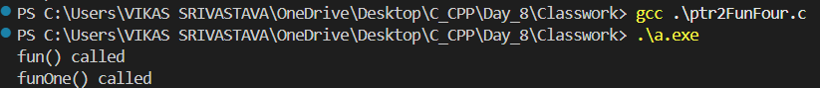

- Code : Write a program to demonstrate function pointers in C++ using the using keyword to define a function pointer type, and invoke different functions dynamically through a common caller function.
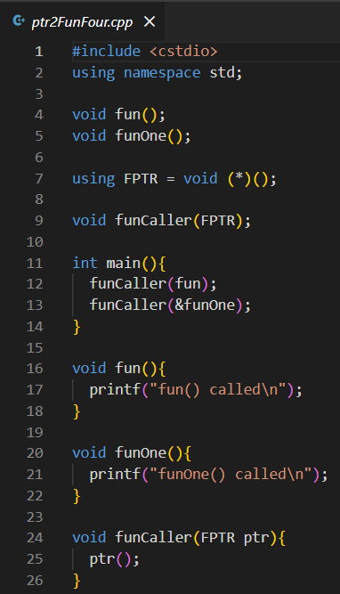

Output :
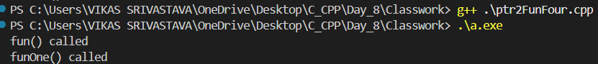

- Code : Write a program to demonstrate basic function pointer usage in C, including declaring a function pointer, assigning it the address of a function, and calling the function indirectly using the pointer.
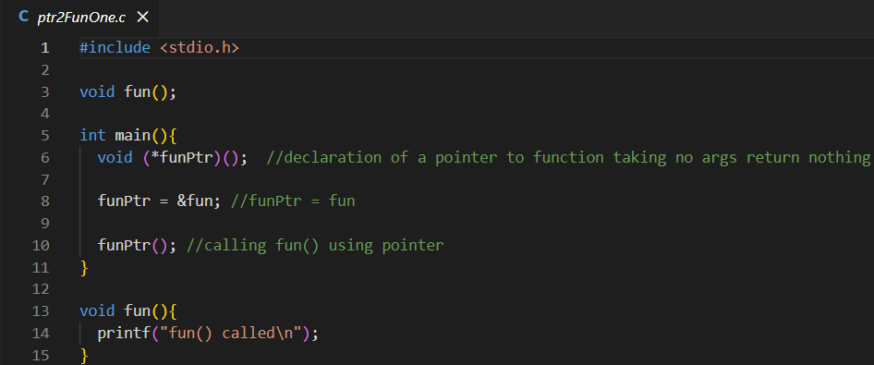
Output :

- Code : Write a program to demonstrate how function pointers can be passed directly as function parameters in C and invoked inside another function, showing both direct and dereferenced function pointer calls.
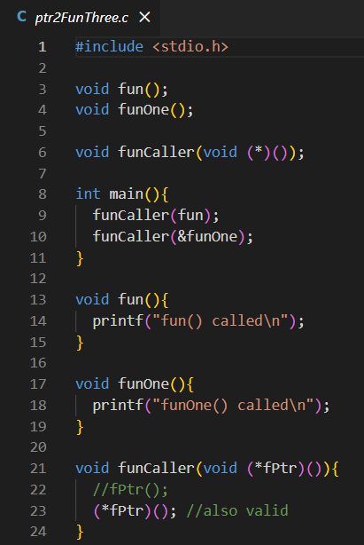
Output :
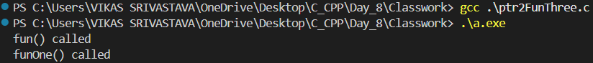

- Code : Write a program to demonstrate how a function can be passed as an argument to another function in C using function pointers, allowing the called function to execute the passed function dynamically.
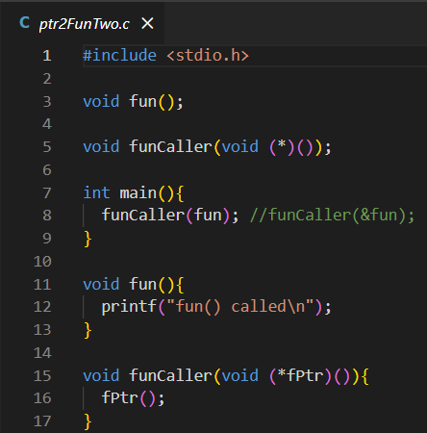
Output :

- Code : Write a program to demonstrate an abstract class in C++ using a pure virtual function, where the base class cannot be instantiated and the derived class provides the function implementation to achieve runtime polymorphism.
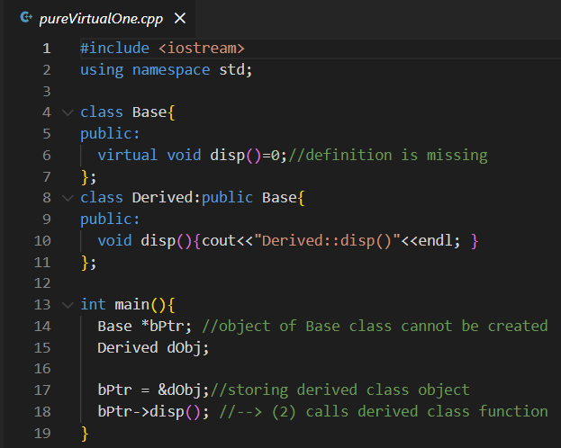
Output :

- Code : Write a program to demonstrate advanced function pointer usage in C, where the address of the printf function is typecast to an integer type and back to a function pointer, and then invoked to print output, illustrating type casting and indirect function calls (for learning purposes only).
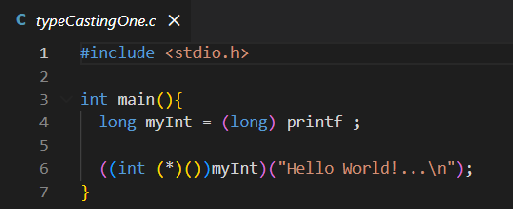
Output :

- Code : Write a program to demonstrate hybrid inheritance in C++, where a derived class inherits from multiple base classes that share a common ancestor, and the scope resolution operator (::) is used to resolve ambiguity when calling base class member functions.
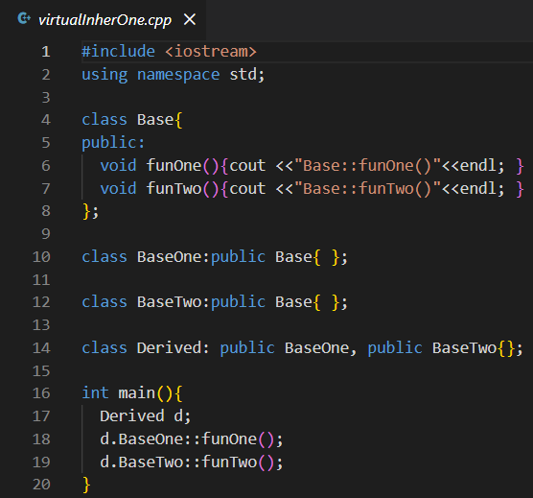
Output :
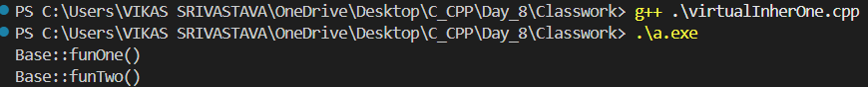

- Code : Write a program to demonstrate virtual inheritance in C++, where multiple derived classes inherit from a common base class virtually to avoid duplicate copies of base class members (diamond problem), allowing the final derived class to access base class functions without ambiguity.
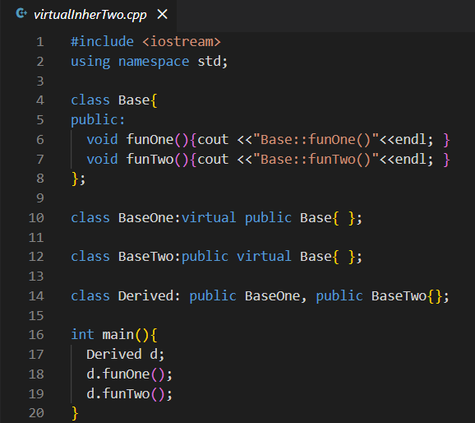
Output :
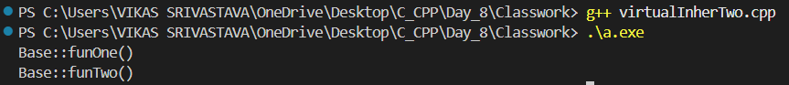

- Code : Write a program to demonstrate runtime polymorphism using virtual functions in C++ and explain the internal working of virtual function calls through the virtual table (vTable), showing how function calls are dynamically resolved at runtime based on the actual object type.
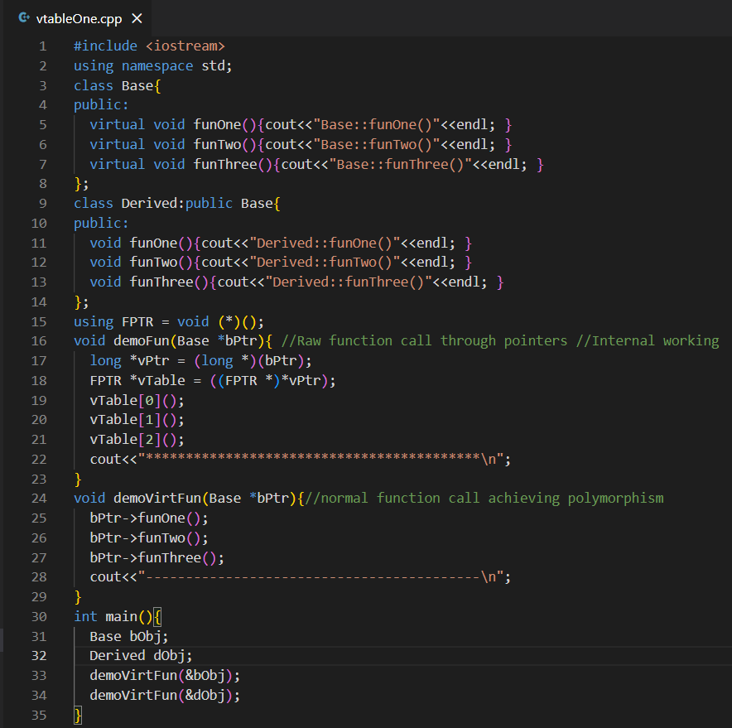

Output :
